

**Internet Programming Laboratory (CSE 326)**

**Synopsis**

**On   
“Blood Donation Website”**

**Submitted To:**

**Dr. Dhanpratap Singh**

**Submitted By:**

**Name: Preethi Muppala Sammetla Neelima Devi Ambakanti Vyshnavi**

**Section: K19PA K19PA K19PA**

**Reg. No: 11911980 11911843 11902104**

**Roll No: 03 44 19**

STUDENT DECLARATION

This is to declare that this report has been written by us. No part of the report is copied from oher sources.All information included from other sources have been daily acknowledged. We aver that if any part of the report is found to be copied, we shall take full responsibility for it.

M.PREETHI

ROLL NO: 1

A.VAISHNAVI

ROLL NO :19

S.NEELIMA DEVI

ROLL NO :44

Place: Visakhapatnam

Date: 09/04/2020

TABLE OF CONTENTS

TITLE PAGE NO.

1.Background and objectives of project assigned……… 1

1.1 Project overview 1

1.1. 1 Project Description 3

1.1.2…………………………………………………………. 5

1.2...………………………………………………………….. 7

1.2.1…………………………………………………………. 7

1.2.2…………………………………………………………. 9

1.2.3……………………………………………………….. 10

2. Description of Project……………………………………. 14

2.1 …………………………………………………………… 17

2.2 ………………………………………………………….. 18

PROJECT OVERVIEW:

Keeping this in view of the blood donation is the most important task and it must be faster an efficient as the demand is very high. Manual donation is completely ruled out and it requires an efficient program to implement reservation.

The Blood donation agent is to create an e-Information about the donor and organization that is related to the donor.There are also details to contact us for any queries regarding the blood donation. This website will help thousands of people lives where blood is in need. As we can see, the website asks you to sign up which clearly mentions that the account is free and it always will be which means it doesn’t cost any charges unlike other websites which charges you to sign up. To create this account at first we have to fill in the personal details of the donor who signs up in the website. It asks to fill the name and email address which is followed by confirmation of email address and asks to sign up with the security password. To follow the rules and regulations of donating blood it asks you to fill up the date of birth which calculates your age and then if the user is above 18 years old it signs you up

takes care of the patients and if the user is not above 18 years old it doesn’t allows you to sign in and asks you to sign in after the completion of 18 years old of the user.

This website also provides the information of how a person can save the lifes of thousands of the people by donating his blood and the precautions they take while the blood donation procedure is going on and how they.

It also provides you the reasons why one has to donate blood and what are the benefits of donating blood and how it works out. There are also some options where you can refer this website to your friends to fill this up.

PROJECT DESCRIPTION:

This project is aimed to developing an online Blood Donation. The entire project has been developed keeping in view of the distributed client server computing technology, in mind.

The Blood Donation agent is to create an e-information about the donor and organization that are related to donating the blood. Through this application any person who is interested in donating blood can register themselves in the same way, if any organization wants to register itself with this site can also register.

Moreover if any general consumer wants to make a request of blood can take the help of this website and asks the person who are available at that time for blood donation. There are also free blood donators and also paid blood donators. To people where blood is unavailable they can contact the paid donators and settle to any price and donate the blood. This website also provides the security of the donator details , where you can only contact the donator through this website to chat and settle for a price and fix the appointment.

Admin is the main authority who can do addition, deletion, and modification if required any.

OBJECTIVE OF THE PROJECT:

This project ais for the development of Blood Donation that facilitates the donators to manage their appointments and the administrators to modify the backend databases in a friendly manner.

DESCRIPTION OF WORK DIVISION IN TERMS OF ROLES AMONG STUDENTS:

Our group has been divided into a group of three where we have to do the work of coding and writing synopsis and final report.

In order to this we have decided to do it in a fair manner so we have divided the work into three where one has to do the coding and the one who writes synopsis has to collect all the information required for the project and one has to write the final report.

WORK DIVISION:

1. M. PREETHI – Coding and In charge of the Website
2. A. VAISHNAVI – Synopsis
3. S. NEELIMA DEVI – Final Report and Collection of Information

In this project M. Preethi is in the charge of guiding the group and to clear the doubts of the group members where she also has to do the coding along with the group and has to made sure that the project has to be completed by the given last date. She has done all the background works and the starting page of the website and also the Blood Donation Site.

Whereas A. Vaishnavi is in the charge of writing synopsis and helps in the coding along the group mates and made sure of requirements of the software and hardware needed for this project. She has done the page of About Us and Contact Us.

Also, S. Neelima who is in the charge of final report and also in the charge of gathering all the information required for the project.She has done the page of Why and Who can Donate Page.

When all the group members has completed their given work , we had to assign and organize it together and finish the work and finish it in a group.

This is the screenshot of our website which is done by our group.As you can see , it asks the user to sign in if the user’s account already exists by logging in using his/her username followed by the password for security purposes. In the website the highlighted yellow colour where it highlights the parts of REGISTER for a new user to sign up , WHY AND WHO CAN DONATE where it explains why one should donate his/ her blood and what are the benefits of it and also who are eligible to donate the blood , ABOUT US and CONTACT US where it provides the information of administartors for any queries or help or to know anyrhing or also for complaints.

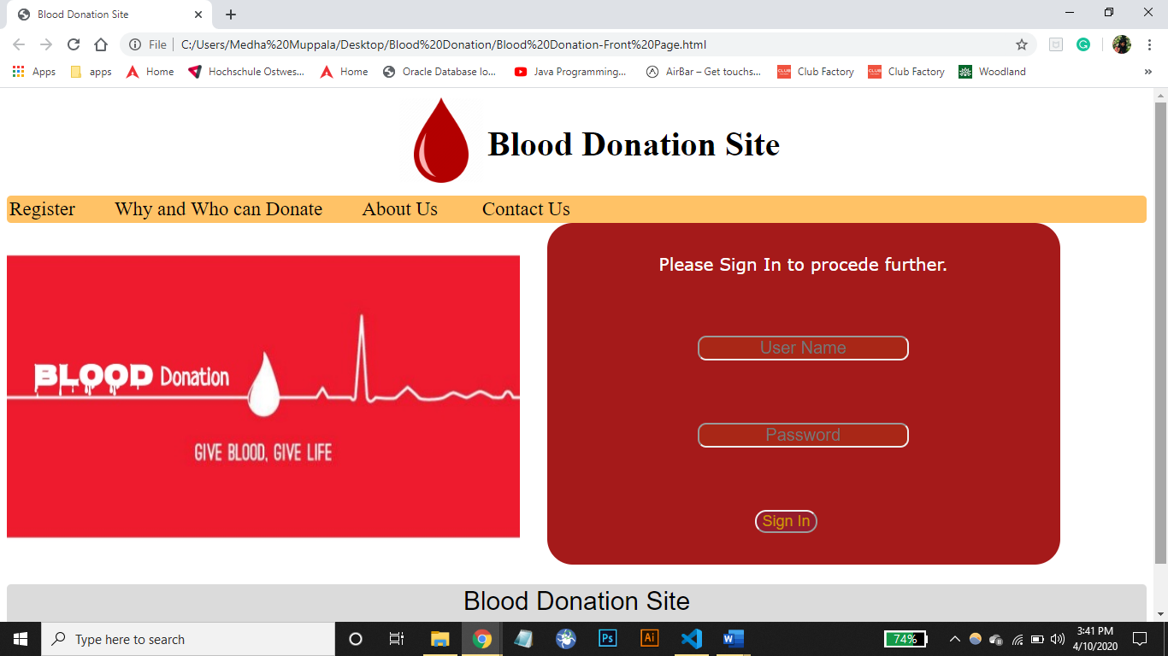

In the below picture , it's a SIGN-UP page where the user has to sign up in order to log in and donate the blood. We can also see the background image is filled with blood bags. Here it's clearly said that it's a sign-up page where we have to fill in the user's personal details such as the user's first name and the last name or surname. To deliver any information regarding the donation of blood or donators, we need the email of the user which is followed by asking the confirmation of email. It is also secured with a password which can be of minimum 6 characters. The date of birth is a must where only the users who are above 18 years old can only sign in, in order to donate blood.

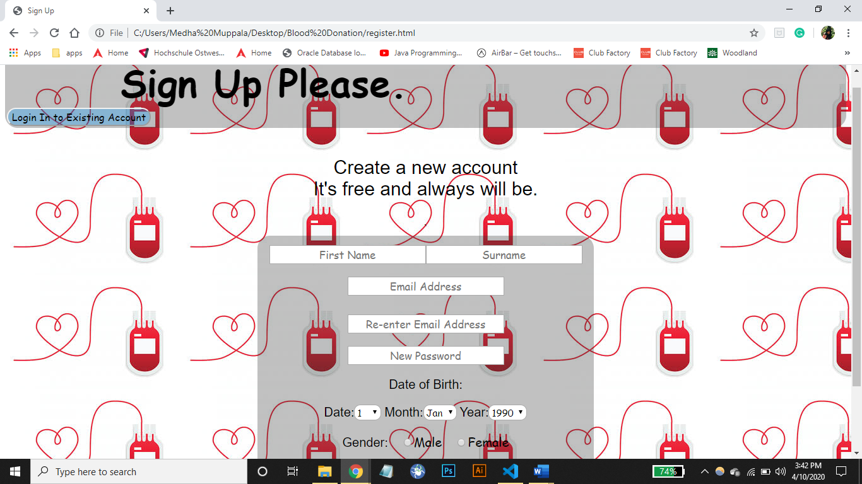

In this picture , it is clearly mentioned about WHY AND WHO CAN DONATE. It provides the information about why a user should donate his blood and what good can happen if he donates, what are the benefits of donating. There are also information about who should donate the blood. Not every person can donate the blood, so in order to know about the things of who can donate , this page provides the information which makes it easier to the user to decide whether the user can donate or not according to the provided information.

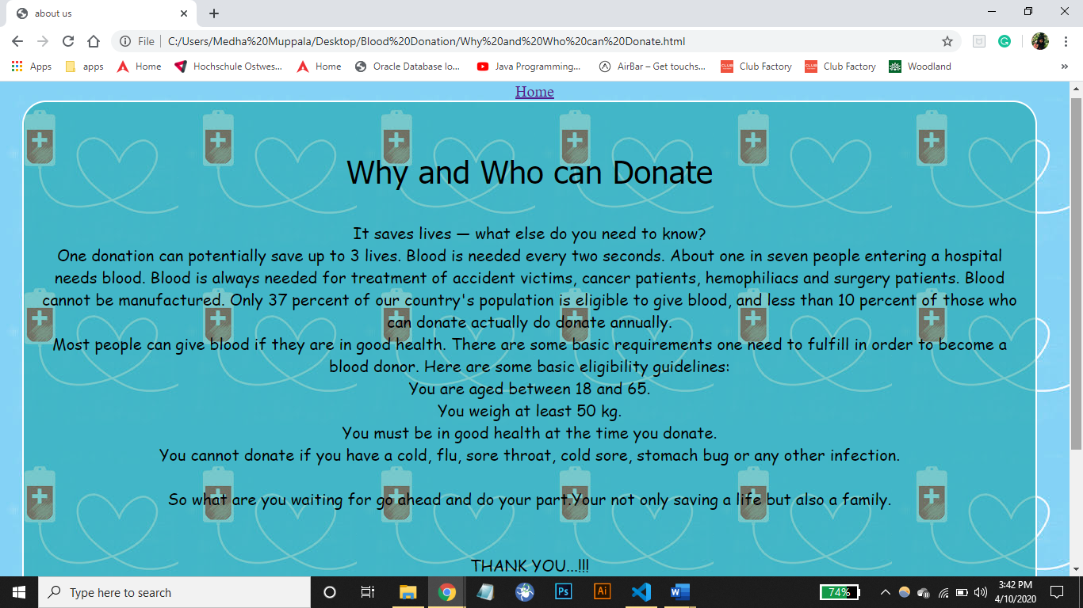

This is a must and should for every website, ABOUT US where it provides the

information about the administrators and also about the information of the website.

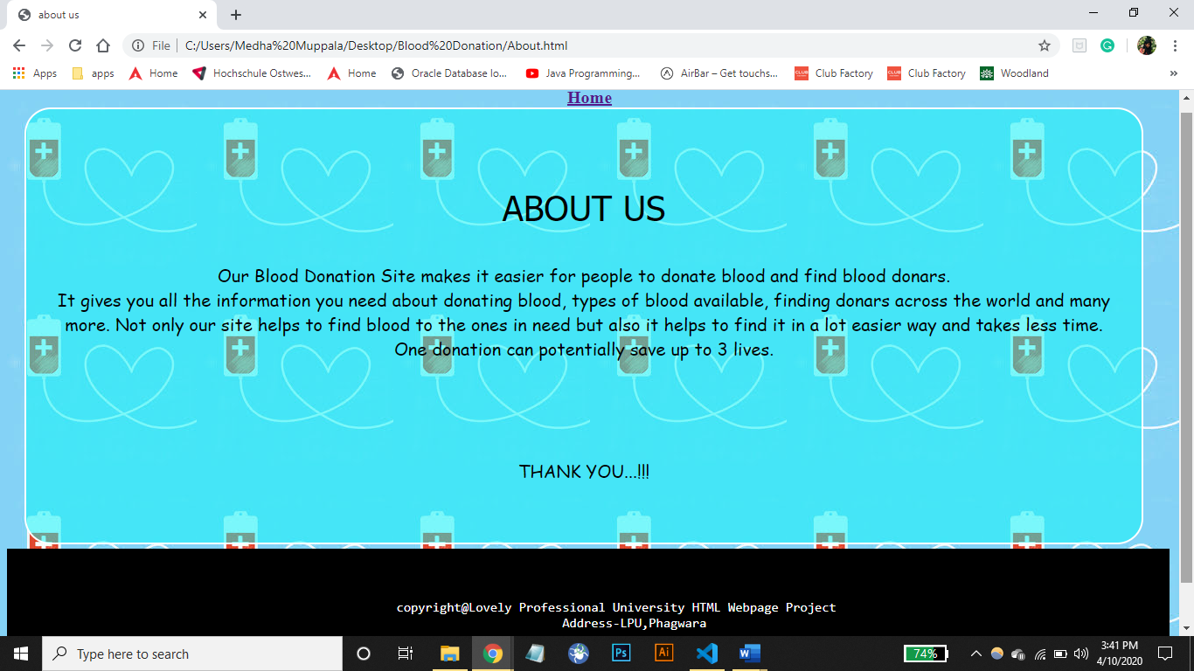

This is the page of CONTACT US where the user will be provided with the information of our website administrators for any queries or regarding any complaints or if the user needs any help. It also asks the user to fill in the information for assistance over eMail where it asks to fill in the name and email if the user and also the SUBJECT where the user is facing difficulty with and in need of the

Assistance.

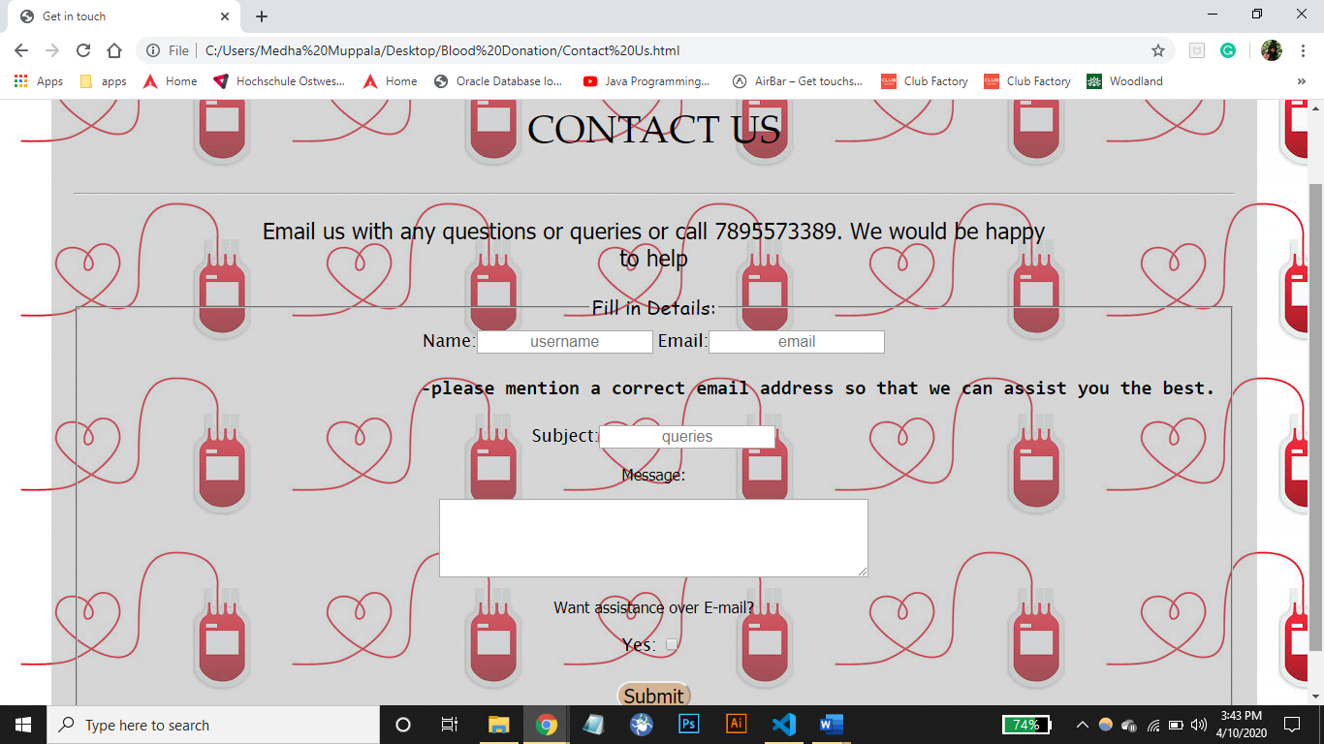

This refers to the blood donation site , where here it provides only three options of REFER A FRIEND, DONATE BLOOD, BACK TO FRONT PAGE . Here you can refer the website to a friend by clicking on the option of Refer a friend and If the user wants to donate the blood , they can click onto the Donate blood button and if the person wants to go back to the front page he can click onto the back to front page.

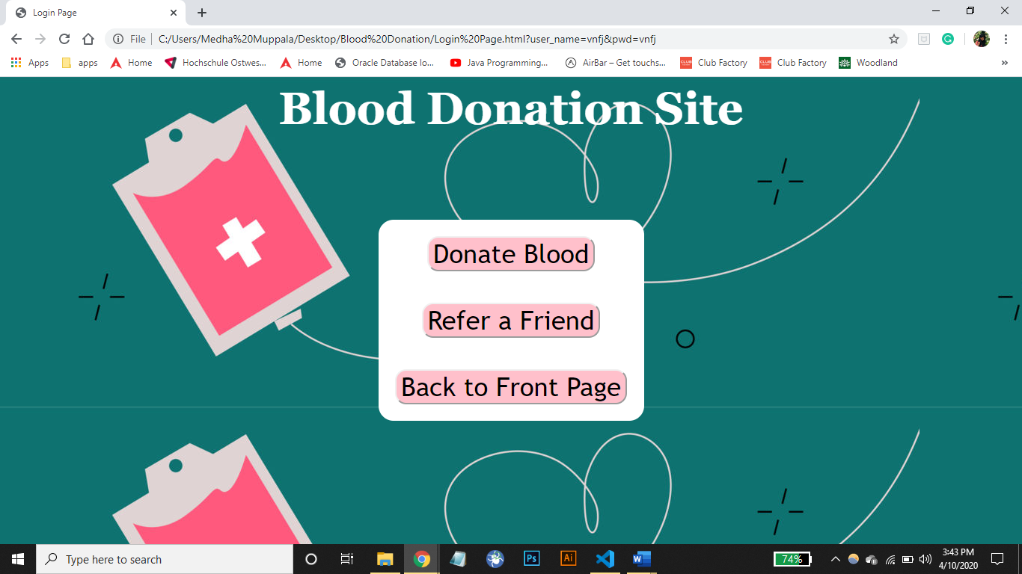

SWOT ANALYSIS:

2.1 INTRODUCTION:

PURPOSE: The main purpose for preparing this final report is to give a general insight into the analysis and requirements of the existing system or situation and for determining the operating characteristics of the system.

SCOPE: This final report plays a vital role in the development life cycle and it describes the complemete requirements of the system. It is meant for use by the developers and will be the basic during testing phase. Any changes made to he requirements in the future will have to go through frmal change approval process.

STRENGTHS:

* User friendliness is provided in the application with various controls
* The system makes the overall project management much easier and flexible
* Readily uploads the latest updates
* Allows the user to download the alerts by clicking the url
* It is a web enabled project
* Easier and faster data transfer through latest technology associated with the computer communication.
* It will increase the efficiency , accuracy and transparency
* Allocating the sample results becomes much faster.
* Decision making process would be greatly enhanced.

WEAKNESS:

* Cannot Upload and Download the latest updates
* Size of database increases day-by-day
* Fewer Users – Friendly
* No Use of Web Services and Remoting
* Risk of Mismanagement of data when the project is under development.

CONTEXT DIAGRAM:

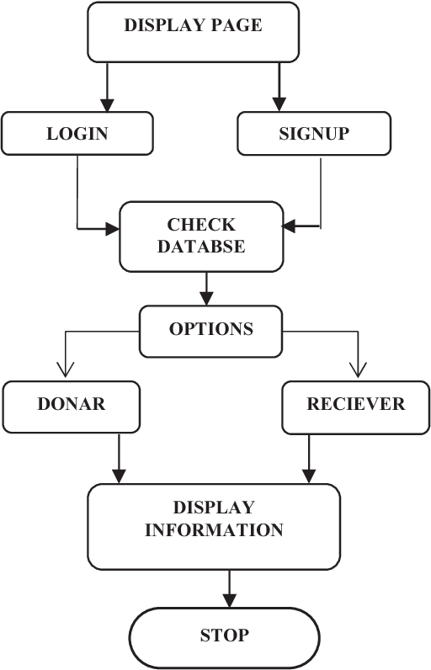

CONCLUSION:

From this topic, we have learnt the very important things that how to use different tags.How to implement this tags in html, css , java script. This project cover all the basic concepts.

REFERENCE:

* W3 School
* Some Random Website to know the definition of the tags

BONAFIDE CERTIFICATE

Certified that this project “BLOOD DONATION” is the bonafide work of “ M.PREETHI, A. VAISHNAVI, S.NEELIMA DEVI” who carried out the project work under my supervision.

Dr. Dhanpratap Singh

CSE-326 INTERNET PROGRAMMING

LABORATORY

UID-25706

School of Computer Science and Engineering